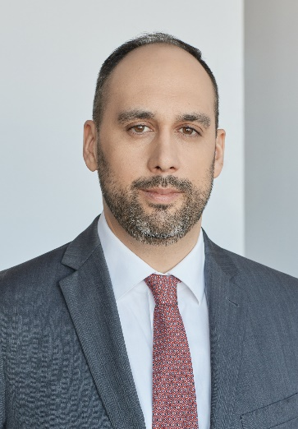 | ERIC BÉDARD, B.A., B.C.L., LL.B.  514-982-1736  ebedard@woods.qc.ca  Member of the Quebec Bar since 2010  Languages: French, English

REPRESENTATIVE MANDATES

- Major commercial disputes: key member of the team that defended the interests of the consortium involved in the failed privatization of BCE Inc. (break up fee litigation), including obtaining a decision in the pending proceedings with a significant strategic impact, and of the team that represented FCA Canada Inc.'s interests against Coopers & Lybrand (saga Castor Holding).

- Contract litigation: significant expertise in disputes in the telecommunications and technology industries: wireless networks, royalties, signal piracy, private financing, software licenses or resale and related royalties, or between customer and supplier.

- Franchisor-franchisee litigation: successful representation of franchisors, franchisees or entities involved in distribution agreement and manufacturing agent disputes. Notably, had the action of a manufacturer's agent against a distributor of sports clothing and accessories because of the breach of their agreement dismissed for serious reasons.

- Shareholder disputes: representation in conflicts and oppression proceedings for minority and majority shareholders and other stakeholders in private and public companies, in Quebec and federal jurisdictions.

- Natural resources: significant expertise in contentious matters involving junior mining companies, geology and engineering service providers related to this type of project, including the acquisition, transfer, publication of mining and gas rights and permits, as well as their evaluation and disclosure requirements incumbent upon their holder, and revenue sharing

- Urgent recourses: substantial experience with safeguard orders and provisional injunctions, including Anton Piller (as counsel and independent supervisory lawyer) and Norwich orders; very familiar with enforcement or rights preservation measures (seizure before judgment, seizure-execution, seizure-reclaim, etc.).
PROFESSIONAL ACTIVITIES AND ASSOCIATIONS

PROFESSIONAL ACTIVITIES
- McGill University, Faculty of Law, co-coach of the team participating at Willem C. Vis International Commercial Arbitration Moot (2018-)
- Centre de développement pour l’exercice de la citoyenneté (CDEC), member of the Board of Directors (2013-)
- Member of the executive committee of the International section of the Canadian Bar Association – Québec Branch (2013-2019).
- Co-lecturer at McGill University, Faculty of Engineering, « Law for Architects and Engineers » (2012-2017).
- McGill Legal Information Clinic, Research Director and member of the Board of Directors (2008-2009).
- Quebec Research Centre of Private and Comparative Law, Researcher and member of the Board of Directors.

ASSOCIATIONS
- ICC Canada, member of the Arbitration Committee (2019-)
- Young Canadian Arbitration Practitioners (YCAP), member of the Board of Directors (2018-) and Vice-President – Events (2021-)

EDUCATION

2009 McGill University, Faculty of Law
B.C.L./LL.B.
2009 Quebec Court of Appeal
University student clerkship, with Justices André Forget and André Brossard

2005 McGill University, Faculty of Arts
B.A., Honours in Philosophy, 1st rank honours
Minors in Political Economy and Theoretical Linguistics

PUBLICATIONS ET CONFERENCES

- Canada chapter in Enforcement of Investment Treaty Arbitration Awards – A Global Guide, Second Edition, ed. Julien Fouret, Castaldi Mourre & Partners, Globe Law, 2020, co-authored with Stephen L. Drymer.
- Canada Chapter in the International Arbitration Review, ed. James H. Carter, Eleventh Edition, 2020, co-authored with James A. Woods, Dina Prokic, and Charbel G. Abi-Saad
- “The Contribution of Canadian Law to International Mining Arbitration” in The Guide to Mining Arbitration, ed. Jason Fry and Louis-Alexis Bret, Global Arbitration Review, October 2019.
- « Les accords commerciaux globaux et la modernisation de l’ALÉNA », panelist on the Investment Chapter (Chicago, Montreal, Guadalajara).
- “Canada-Québec – Dispute Resolution”, in Getting the Deal Through, july 2018, as co-author with James A. Woods and Marie-Louise Delisle.
- « Secret professionnel de l’avocat et transaction commerciale complexe : un privilège relatif aux négociations? » in Développements récents en droit des affaires, vol. 371, Yvon Blais, 2013, as co-author with James A. Woods.
- “The Process of a Typical Commercial Case - Canada (Québec)” in Litigation Guide – IBA Litigation Committee, July 1st, 2013.

